install VBCABLE_Setup_x64.exe and restart pc https://vb-audio.com/Cable/

https://ffmpeg.org/download.html add this in environment variable

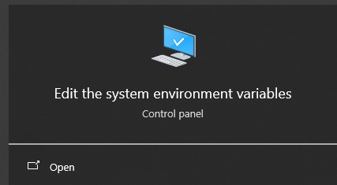

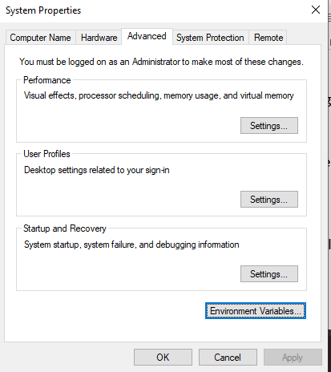

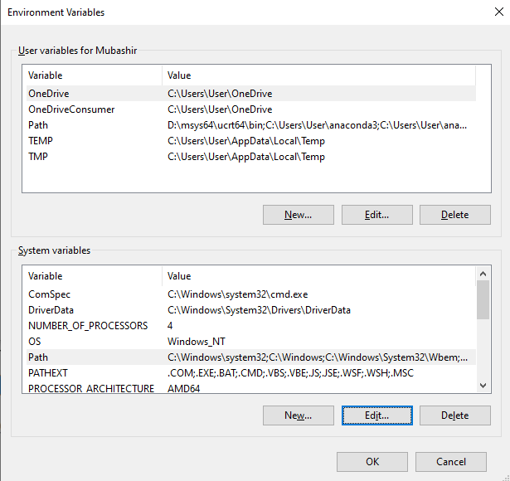

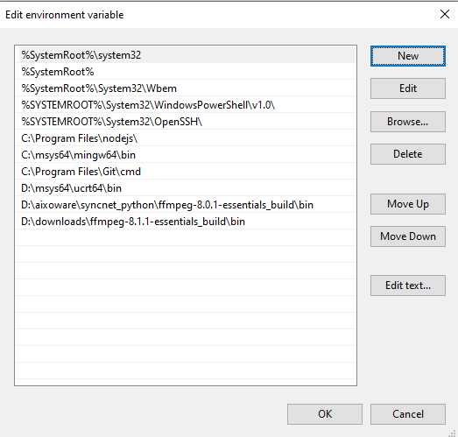

settings - system - sounds - in output choose your output device select CABLE input(VB-Audio virtual cable)

and then install SF-Voice-AI-1.0.0-windows-setup.exe

